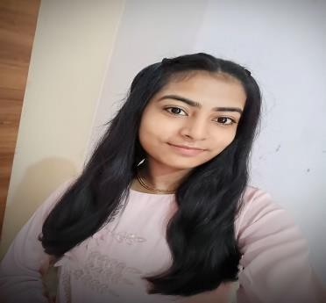

MANSHI GOYAL

Phone: [8006291030
]

]

LinkedIn: [
https://www.linkedin.com/in/manshi
-
goyal
-
102309309
]

Location: [Delhi
]

Education
B.Tech – Electronics and Communication Engineering
Banasthali Vidyapith, Rajasthan
CGPA: 8.08 | 2023 – 2027

TECHNICAL SKILLS
Languages: C++, Python, JavaScript, Java
Core Concepts: Data Structures & Algorithms, OOPs
Frontend: HTML, CSS
Tools: Git, VS Code
Currently Exploring: AI-based Web Applications

PROJECTS
- Smart Mirror (In-House Project – Ongoing)
Tech Stack: Python
Developed an AI-based web platform to help users organize and recall thoughts efficiently
- AI Memory Recaller Website (Hackathon Project)
Tech Stack: HTML, CSS, JavaScript
Developed an AI-based web platform to help users organize and recall thoughts efficiently

Experience / Participation
Web Development Intern – CodeAlpha & CodSoft (1 Month Each)
- Developed responsive web applications using HTML, CSS, and JavaScript; completed assigned frontend tasks and mini projects.
- Strengthened DOM manipulation, UI structuring, and clean code practices through structured project submissions.

